Children and families are at the centre of all circles, interconnected with all things. The wellness of the children and families indicates the wellness of the community.

As part of the Mississaugas of the New Credit First Nation community, we believe in supporting the wellness and the interconnectedness of children, family, community, and the Earth. On this journey, we support the development and understanding of: Interdependence, Gratitudes, the 7 Teachings, and Learning.

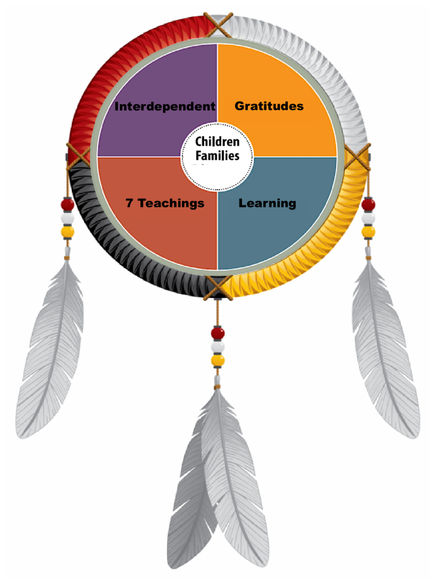

We believe that community, local to world-wide, is about interdependence and connectedness, and we support working together with others and with nature, supporting each other and our environment, and respecting the impact we have on all things.

We honour all things through gratitude, being grateful for everything, every action, every relationship, and every life lesson.

We use the 7 Teachings of Wisdom, Love, Respect, Honesty, Humility, Bravery, and Truth to guide us with our interactions, role-modelling, and teaching.

We believe that learning happens through experiences – exploring, interacting, and relating with others and our environment.

Nimajii-toomin Maamwi: We are on this journey together.
Miigwech

