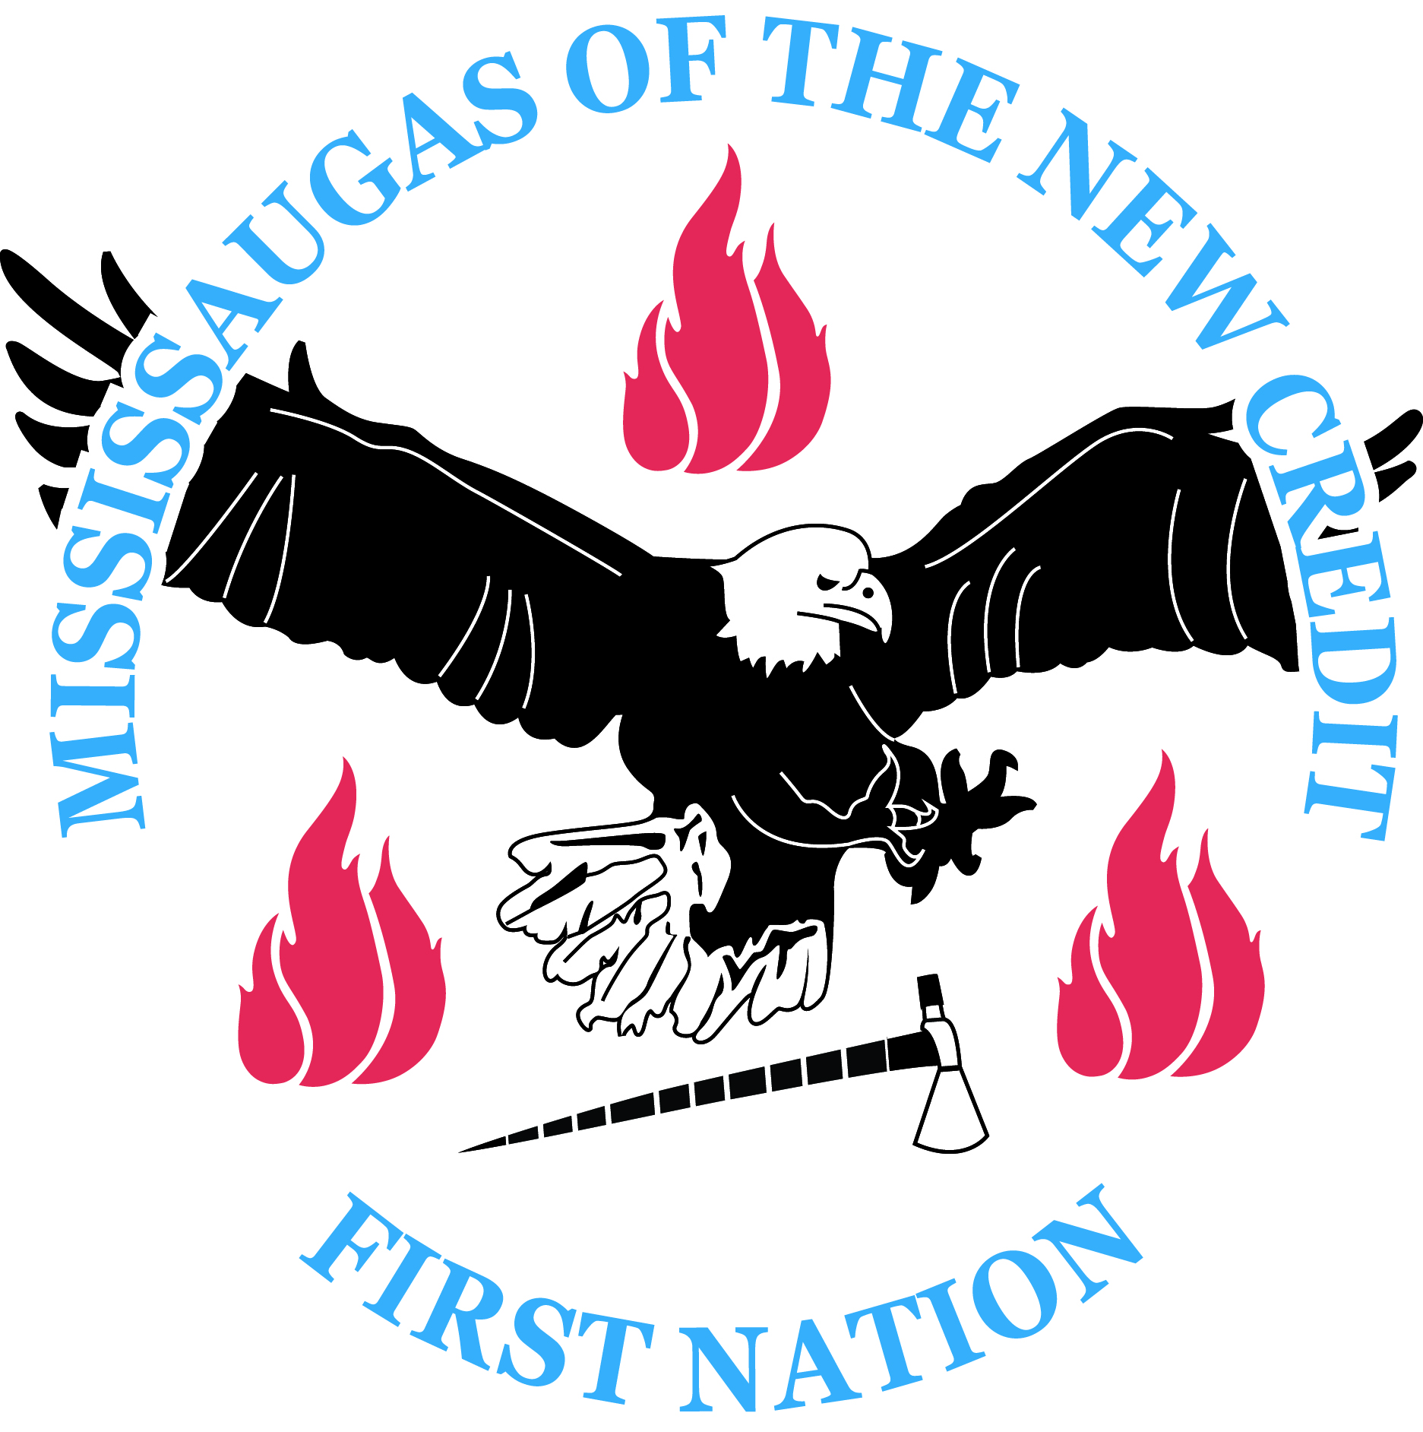The MISSISSAUGAS OF THE NEW CREDIT FIRST NATION
is accepting applications for the contract position of
“Milton Presentation Centre Representative”
Closing Date: June 1st/2017 at 12:00pm
Job Summary:
The Milton Presentation Centre Representative is responsible for central reception and providing support to the representatives of the Milton Logistics Hub Project.

Please note that this position will be required to report to the Milton Presentation Centre for their shifts.

Educational Qualifications/Minimum Requirements
- Grade 12 or equivalent plus 5 years of related work experience
- Working knowledge of a multi-line phone system
- Working knowledge of the use of office machines: fax, photocopier and shredder.
- Solid background in computers, with specific knowledge of Microsoft Office and Excel.

Other Requirements
- Must possess a valid driver’s license, proof of insurance and a reliable vehicle as travel is required
- Must be willing to work flexible hours, including weekends

Assets
- Ability to work cooperatively with other staff and management
- Ability to relate effectively to community members
- Strong written and oral communication skills
- Strong interpersonal and organizational skills
- Ability to multi-task and work productively in potentially stressful situations

Wage: Hourly rate of $16.428. Start date would be as soon as possible.

Hours: Position is based on a minimum 16 hour work week (4hr days, 4 days per week). In addition, travel time and mileage will be provided. Please note, this position may be subject to additional hours based on client needs.

Please submit your cover letter, resume, proof of educational qualifications and three (3) current references, with two (2) being work related if possible to:

The Mississaugas of the New Credit First Nation
Attention: Personnel Committee
2789 Mississauga Road
RR#6 Hagersville, ON
N0A 1H0

Applications will also be accepted by fax at 905-768-1225 or via email at the address listed below.
A detailed job description is available at the New Credit Admin Building or by email at Kerri.King@newcreditfirstnation.com
Miigwech to all who apply, only those candidates selected for an interview will be contacted. For this opportunity, a member of the Mississaugas of the New Credit First Nation is preferred. Please note, incomplete applications will not be considered.

